Weekend away: Farm bounty in southwest Iowa
- Article by: BETSY RUBINER , Special to the Star Tribune
- Updated: May 31, 2013 - 1:47 PM
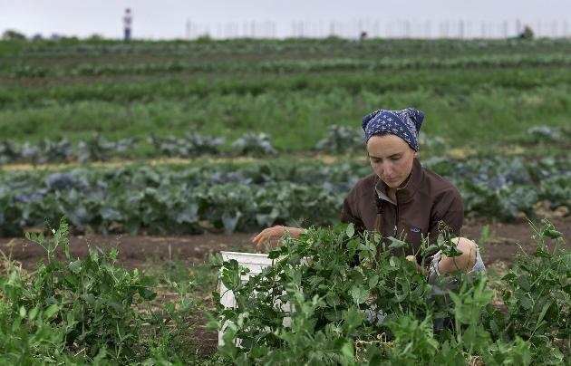
hide
The Henry A. Wallace Country Life Center includes a community-supported agriculture garden, managed by Sarah Costa, above.
Photo: Gary Fandel • Iowa Farm Bureau,
Star Tribune photo galleries
view larger
- 0
- comments
- resize text
- print
- buy reprints

Before he was vice president in the 1940s and before he popularized the use of hybrid seed corn, dramatically boosting harvests, Henry A. Wallace was a farm kid in southwest Iowa. Today, visitors to the old Wallace farm in Adair County wander through restored prairie, admire flower gardens and dine on the farm’s bounty. In and around Greenfield, the county seat, other charms await — a recently restored opera house and hotel, a vintage aircraft collection and a 60-ton boulder repainted annually with a new design honoring U.S. military veterans.
THE BASICS
With 1,982 residents at last count, Greenfield is about 60 miles southwest of Des Moines. Outside town, in classic Iowa farm country, a hawk soars high above green fields. (Hence the town’s name.) Red-winged blackbirds flit across a roller-coaster two-lane road. White clouds in a blue sky cast shadows that drift across a grassy hillside where black cattle graze. On the horizon, beyond an abandoned windmill, two massive wind turbines whirl.
In town, where an 1891 red brick courthouse dominates the small public square, it’s quiet on a spring weekday.

WHAT TO DO
Explore the farm: A scenic 10-mile drive from Greenfield (Hwy. 92 east to P33 south) leads to the birthplace farm of the most influential Iowan of the 20th century, as Henry A. Wallace was dubbed by the Des Moines Register. An advocate of progressive agricultural practices, Wallace (1888-1965) also served as U.S. secretary of agriculture during the 1930s and founded the hybrid seed corn company now known as DuPont Pioneer.
Today, the Henry A. Wallace Country Life Center, in tiny Orient, Iowa, is a picture-postcard-perfect farm, with 40 of the original 160 Wallace acres including 9 acres of restored prairie and a small pond, plus themed flower gardens, produce gardens, an orchard and a ¾-mile prairie walking trail dotted with sculpture. The Wallace Center’s farmhouse now houses a gift shop. Inside a large white barn-like building — constructed in 2003 to resemble the farm’s original barn — is the Gathering Table, a restaurant serving fresh country food with a flair.
Hours for the center’s offerings vary so check its website. The grounds are open daily for self-guided tours. (1-641-337-5019; 2773 290th St., Orient; www.wallace.org).
Wander historic downtown: In Greenfield’s compact public square, the 19th-century courthouse is surrounded by well-kept old storefronts. Most impressive is the three-story former opera house with its copper turret, circa 1896, which reopened in 2012 as the Warren Cultural Center after a $6.2 million makeover. The Cultural Center now offers occasional live music and theater in the restored auditorium upstairs, which had last been used in the 1940s. (1-641-343-7337; 154 Public Square, Greenfield; www.warrenculturalcenter.com).
On the street level, Ed & Eva’s sells work by many Iowa artists. Nearby is J’s Variety, selling vintage goods, and Colors Floral and Home Decorating.
Admire flying machines: Inside a hangar about 2 miles north of downtown, the Iowa Aviation Museum showcases decades of flight, starting in the 1920s, with a display of 15 early aircraft, from gliders to small planes. (1-641-343-7184; 2251 Airport Rd., Greenfield; www.flyingmuseum.com).
Reflect at the rock: About 11 miles farther north on Hwy. 25 (and a mile south of Interstate 80’s exit 86) sits the Freedom Rock, the ongoing project of Ray “Bubba” Sorensen II. Every year before Memorial Day, Sorensen paints a different mural on the boulder as a thank-you to veterans. Passersby from all over have signed the visitors log. (www.thefreedomrock.com)

WHERE TO EAT
At the Wallace Center’s Gathering Table, chef Katie Routh concocts creative lunches and dinners with seasonal ingredients. The lunch menu may include a vegetable tart using the Wallace Center’s produce, braised beef roast penne, and ginger frozen yogurt with chocolate curry truffles. The restaurant offers lunch and dinner Fridays only, year-round except between Christmas and Valentine’s Day. Some dinners include live music. Dinner also is served on the first Saturday of the month, May through December. Reservations recommended (1-641-337-5019; www.wallace.org).
In Greenfield, Los Altos is a popular Mexican restaurant (1-641-221-9081; 302 Kent St. SE.).

WHERE TO SLEEP
Reopened in 2011, the brick 1920 Hotel Greenfield is a gem, with 20 bedrooms individually decorated with antiques and art, plus a restored period lobby. No plastic room key cards here. The original metal keys are used. (1-641-343-7323; 110 Iowa St. E., Greenfield; www.hotel-greenfield.com).

IF YOU GO
For more information, call the Greenfield Chamber (1-641-743-8444; www.greenfield iowa.com).

Betsy Rubiner is a Des Moines-based travel writer.

